Ruahine Forest Park Visitor Facility Network management Review

Notes from Meeting One
13th August 2012

Present: Tony Gray and Lindsay Forrest (Rangitikei TC), David Branford, Ridgeway Lithgow (Wanganui T C), Glenda Hooper and John Montgomerie ( Heretaunga TC), Janet Wilson and Anne Lawrence (PNMTC), Jean Garman(MTSC), Julia Mackie (Napier TC), Michael Charlton (Ruahine NZDA),), Vince Payne (Dannevirke NZDA), Dennis Moore & Stuart penny (Manawatu NZDA), Rob Wallace (Hastings NZDA) Owen Cox (FMC), Andrew Mercer, Ken Mills, Jason Roxburgh, Mike Davies and Gavin Walker(DOC)

Apologies: Steve Silcock (Wairarapa Bush NZDA, Steve Howe (Taihape NZDA),

Welcome and introductions

- Up dating the Process: Jason Roxburgh

The intent of the working group process is to focus on what we can do together to provide a valued and well utilised recreation network that is relevant, sustainable, and fits well in the context of the other places and opportunities in the lower North Island.

Your feedback identified that our communication did not clearly explain to all the intent and goals of the process. Given that, the process will be undertaken over a longer timeframe, with wider representation, and with improved clarity on the working group goals. Some present on the night asked what additional points of view not already represented were asking to be involved. These include Hutt Valley Tramping Club, a Taranaki hunting club, the Central Hawkes Bay Park Users Association, The Lower North Island Hunter Liaison Group, one business, and six individuals not associated with clubs.

It is encouraging that the working group represents a significant group of people that choose to spend their leisure time in Ruahine Forest Park. I really appreciate your continued involvement in this group, as we work together to confirm what the Ruahine Forest Park’s visitor facility network requires to better meet peoples’ needs now and into the future.

Jason asked for feedback from those present as how long they thought the process should take and what ‘Collective ownership” or agreement of the outcome at the end of this process might look like.

- Ruahine Forest Park in a national context: Gavin Walker.
Talked about how DOC is aiming to get more people engaged in Recreation and how the Ruahine Forest Park might fit into this. Gavin’s notes, including the summary of use data for Ruahine Forest Park, and back ground information on the destination Management Framework approach DOC is taking nationally are attached as Appendix One. The explanation of depreciation and capital charge Gavin mentioned will be available shortly. A review of the current management agreement for volunteers undertaking recreation/historic work is under away and should be available before Christmas.

- Terms of Reference:

No further Changes were proposed and it was agreed that we move forward under these terms. However, if (as suggested at the meeting) we move to form a Ruahine Working Group, the TOR would be rewritten

- General Business:

- DOC adheres to the Health and Safety in Employment Act, which requires us to treat volunteers working with/on behalf of DOC the same way as staff in relation to health and safety. This means we require them to have the same level of qualification and competency as DOC staff must have to operate chainsaws and other power tools used for track maintenance.
- The Concept of one group representing recreational users of the Ruahine Forest Park was proposed, with the Permolat (www.remotehuts.co.nz) group from the South Island mentioned as a model. It was agreed that this warrants further investigation, and could be useful for collaboratively managing the Ruahine opportunities.
- Manawatu Rangitikei Area currently uses a Management Agreement process for vesting management of a Hut or Track with a club. This is a legal contract that protects both parties, ensures that both parties’ expectations are the same, and makes sure rights and responsibilities are clearly understood. Some groups expressed their desire to take on the management of facilities, but this long document puts them off. As Gavin Walkker mentioned, a review of the current management agreement for volunteers undertaking recreation/historic work is under away and should be available before Christmas.
- Users would like to know about the state of the huts and any minor work they could help with, when they are planning a trip so they could go prepared.
- The Ruahine Corner Air strip is not recognised by DOC or CAA as an airstrip, and is not maintained as such. Therefore its use is, and will remain, entirely at the pilot’s risk and discretion

- Priorities for the Ruahine Forest Park:

Janet Wilson PNTMC had prepared written notes, see Appendix Two. The main points were;

- Opposed to the removal of any assets in the Ruahine.
- Not in favour of a booking system for huts
- Would like to see Mid Pohangina bridge re built, and tracks cut between Otumore and Howlett’s and through the Waipawa saddle.

Jean Garmen MTSC had prepared written notes, see Appendix Two. The main points were;

- Keep a range of opportunities
- Tracks through Leatherwood very important
- There is a bare minimum of huts

Dave Brandford WTC said his Club were still preparing the information, though said it will be similar to the first two clubs.

Stuart Penny and Dennis Moore of the Manawatu NZDA said toilets at road end were a great idea. All huts should stay.

Vince Pain and Michael Charlton of the Ruahine NZDA were of the opinion that once huts are gone they are harder to replace, so effort should be focused on looking after these first.

Tony Gray and Lindsay Forrest RTC expressed their desire to keep facilities close to there base, like Kawhatau Base and Kelly Knight Hut. Access was important to them

Rob Wallace (Hastings NZDA) wants markers left on tracks if they stop being cut. Question the cost of removing a hut versus the cost of just fixing it. Asked if a hut was removed then would a campsite be maintained instead.

Julia Mackie (Napier TC) reported they have 28 club trips planned into the Ruahines this year, and wants to keep everything as it is in the Ruahine. Can’t understand why the Ruahine is struggling when she reports her enquiries to “the DOC Kaweka guys” say they “have money coming out their ears”. For further information see Appendix Two.

Glenda Hooper and John Montgomerie (Heretaunga TC) were against the removal of any huts or tracks. Ranking the opportunities in the Ruahine was difficult, but safety, access, multi use, education, and families should be considered.

- Potential Cost Saving Strategies that a Working Group could work on

- Don’t cut tracks so wide, or as often
- Signs don’t need to be big or as flash as Rimutaka Forest Park
- Lower standards for all facilities
- No flash road ends or Iron Gates
- Less road end mowing
- No gas cookers or heating in huts

- A Summary of Recommendations for comment

After some post-meeting discussion, the points below may be a way forward, and DOC is keen to discuss these at the next meeting. Your feed back and priorities are still very relevant, but with the focus moving to possibly establishing a Working Group we thought these suggestions could guide our work together:
- That DOC seek commitment from those attending the meeting to form a Ruahine Working Group, with the purpose of establishing an ongoing relationship that reflects the valued recreation opportunities in the Park, and the management of the area.
- That the next meeting focuses on establishing the Working Group, and how we work together.
- That Terms of Reference for the Review are revisited, to reflect an ongoing Ruahine Working Group.
- That, if established, the Working Group is based on the following premises:
- the opportunities provided into the future need to change to meet nationally changing recreation demand by the wider community
- Achieving DOC’s strategic direction of getting more conservation work achieved through engagement and collaboration, and “more people involved in recreation”
- That hunters and trampers have differing aspirations for managing the network, and there is a wide spectrum of views within each user group.
- That it is becoming difficult for DOC to sustain the current network at the standards it is currently being maintained at.
- Once the Working Group is established, that the ideas presented by the parties at the last meeting (as to the parts of the network that they most value) are used as a basis for a planning discussion on the future of the network.
- That the Working Group helps develop options for community management.
Next meeting: Monday 17th September 7pm DOC office Palmerston North

Meeting concluded 9.20 pm


Destination Management Fact Sheet
What will Destination Management mean?

Destination Management Framework

November 2011

What is the Destination Management Framework?
Destination Management Framework is a term for the focus DOC is putting on encouraging more people to participate in outdoor recreation and tourism on public conservation lands and waters. This supports both the SPARC Outdoor Recreation Strategy 2009-15, and the NZ Tourism Strategy 2015. The Destination Management Framework focuses us on 5 key areas for success;

- Basing decisions on better understanding of the preferences visitors and potential visitors have (understanding demand),
- Providing the right mix of opportunities to match that demand (optimization).
- Providing quality experiences that people will remember and tell others about,
- Promoting what is available.
- Sharing the task of managing this great public resource with communities and business (working with others).

All this means participation in recreation at conservation destinations will grow. Not at every place, but overall, over time, and more widely.

Why do we need the Destination Management Framework?
The number of New Zealanders who use conservation areas appears static or possibly declining, with about 50% visiting at least once in the last 12 months. It is not clear that the upcoming generation of New Zealanders are going to be active in the outdoors, being influenced by city focussed living and growing ethnic diversity.

On behalf of all New Zealanders, DOC wants to give more people a chance to make that choice to connect with our land and heritage. DOC also wants to help make some conservation destinations so appealing that international tourism continues to be a significant contributor to the New Zealand economy.

Does this mean DOC is not going to focus on the backcountry?
DOC has decided that it has obligations across four key types of destination:
  - icons that underpin New Zealand tourism
  - gateways that encourage New Zealanders to recreate in the outdoors and to learn about conservation
  - local treasures that provide local places for local people and support regional outdoor recreation needs
  - backcountry networks
The most popular backcountry destinations are classified as ‘icon’ (eg the Milford Track) or ‘gateway’ (easy tramping opportunities eg Holdsworth to Powell Hut in the Tararua Ranges). The rest is what is referred to as the ‘backcountry networks’.

DOC seeks to manage the basic backcountry networks to supports access to New Zealand’s great parks and the remote experiences within. This does not mean DOC must retain all of the existing network, which includes well over 10,000km of routes and tracks, and over 800 standard and basic huts.

By sharing the responsibility of that management with others such as clubs and informal support groups, more facilities can be retained for our backcountry adventurers.

Is DOC just trying to justify reducing its commitments to live within budget?
DOC has a responsibility to manage its conservation activities within budget. But choices about which facilities to manage into the future is much more than a budget issue.

DOC is seeking to balance the interests of a whole range of people – this includes those people who like to picnic and walk their dog at a nearby local reserve, those people who want to explore New Zealand’s backcountry, those people who want an entertaining day or weekend out with the family, and those people who want to experience in relative comfort some of New Zealand’s most spectacular scenic landscapes and heritage sites.

In addition there are the interests of people whose businesses rely on visitors to conservation areas, tangata whenua expectations, and volunteer opportunities. The population of New Zealand is growing and changing, and there is a general concern, not just in New Zealand, that there is a shift away from active use of protected areas in favour of urban-based leisure.

All this means that the current range of opportunities is unlikely to be exactly the same one that will best serve the needs of the future. The balance DOC must seek to achieve will mean some places people think of as great recreation opportunities no longer stack up as important to retain. Hopefully good choices will be made about the places that continue to be managed, and how they are managed. DOC needs your help in making those choices.

How is DOC making these decisions?
DOC wants to ensure that the facilities provided in conservation areas meet the needs of users. This means undertaking surveys and talking with people.
DOC is asking people to get involved in the review of Conservation Management Strategies, when places and issues of importance are discussed. We may not have been the best at doing this in past, but the invitation is there to find someone to talk to about what you think are priorities and why.

DOC is still faced with the day to day decisions of managing destinations, and a balance is needed between discussing what needs to happen and efficiently going about the work.

Each year DOC will develop plans for the delivery of recreation facilities and services that help it achieve the outcome ‘more people participate in recreation’. Priorities will be set reflecting how well this task is being achieved,. Over time change will occur as facilities reach the end of their life and choices are made as to whether replacement is still warranted, or resources will be better used at some other destination.

What priorities have DOC chosen?
The key areas of focus are those destinations that are critical to New Zealand tourism, and those places that help introduce New Zealanders to the outdoors and to learn about conservation. Supporting these opportunities is a range of vehicle accessible locally treasured places, in effect ‘defined’ by the people who use them, and a backcountry network supporting New Zealander’s who seek adventure in remote places.

Comparing these many different places is not easy due to their variety and the attachment people hold to each and every destination. Criteria for assessing different destinations include cost per visitor, which is a crude but generally applicable approach suitable for comparing relatively similar types of opportunity. DOC also recognizes the potential value of places that profile natural and historic features, but which are currently little used. In order to realize that potential, DOC will need to assess how important examples are being managed and promoted. Some facilities are critical for enabling the more adventurous amongst us to access remote areas of our parks, and a wide network of these basic buildings, bridges and tracks will be retained.

Other priorities are leading to changes to this network, with the completion of the Te Araroa Trail stretching the length of New Zealand, new cycleways offering mountain bikers multi-day trips, and more access in the highcountry following Tenure Review. New opportunities are periodically developed or significant redevelopments of tired destinations undertaken.
These will focus on places and types of attraction that are most likely to successfully attract people – consistent with New Zealand’s conservation brand.

New responsibilities, whether from new acquisitions or from new development or upgrades must be balanced with reduced effort elsewhere, either that or alternative management solutions must be found such as community management or finding a commercial partner. These changes are the natural consequence of DOC adopting a more forward looking approach to its contribution to New Zealand’s recreation and tourism opportunities.

Will volunteer effort just mean DOC funds get directed somewhere else?
DOC has a strategic goal to get more conservation work achieved through engagement and collaboration with local and national partners.

DOC is also charged with integrating conservation functions. This means that budgets are not fixed for each function year in year out, but adjusted to meet changing needs and to fit within Government allocations. Basically it is not possible to guarantee that volunteer effort such as in backcountry huts will be a complement to fixed funding for those huts into the future.

What DOC wants is to establish and strengthen its relationships with national and local partners, which comes with engagement around places and visitor opportunities that people care about. Where this has been done, parties involved have seen this as a positive approach that has achieved more than would otherwise have been the case. The Tararua Aorangi Rimutaka Huts Committee is an example.

Is DOC spending more just to meet unnecessary legal requirements?
The existing legislation and codes of practice must be followed. They have been developed as formal controls to ensure risk is kept within acceptable limits, and encouraging best practice.

DOC gets involved in processes of change in legislation and regulation, advocating for appropriate standards. Stakeholder groups also need to use these processes to seek the standards they think should apply.

Use of backcountry opportunities in the Manawatu region

Tramping participation

- The Roy Morgan National Trend of NZers (docdm-1004989) found that in 2011, 4.1% of the population aged 14+ in the Manawatu / Whanganui Region considered themselves to be regular trampers. This compares to 7.3% in Wellington and 7.7% in Hawkes Bay. The national figure was 5.1%

- The 2007/08 SPARC Active NZ Survey (http://www.activenzsurvey.org.nz/) found that 11.8% of the population in the Manawatu aged 16+ had been tramping at least once in a 12 month period. Figures for other regions were Wellington 14.5%, Hawkes Bay 8.2% and Whanganui 11.9%. The national participation rate was 9.4%

- The 2011 National Survey of NZers (docdm-883232) looked at participation in activities on PCL on the respondents’ most recent trip. There was no difference in tramping participation (3%) between The Wellington-Hawkes Bay region and TWT (which in the 2011 survey included Palmerston North).

The numbers are a little contradictory which will be partly to do with having slightly different questions, samples and methodologies. Two of the surveys suggested that there are higher tramping participation rates in Wellington than the Manawatu which along with the higher population in the Wellington region might influence where we choose to invest in facilities in order to meet demand in the lower North Island.

Hunting participation

- The Roy Morgan survey showed that hunting participation is much higher in Manawatu-Whanganui (3.9%) than in Hawkes Bay (0.8%) or Wellington (0.6%).

- The SPARC Active NZ does not provide complete info for hunting as it only lists the top 10 activities overall and for each gender. However it found that 17.3% of males aged 16+ in the Manawatu region had gone hunting in the previous 12 months. Hunting did not register in the top 10 in Wellington or Hawkes Bay so no data is provided. The figure for Whanganui was 17.4%.

- The 2011 National Survey of New Zealanders found that 5% of respondents in TWT Conservancy (which in the 2011 survey included Palmerston North) had hunted on PCL on their most recent trip. The figure for Wellington-Hawkes Bay was 1%.

These surveys together suggest that hunting use is significantly higher in the Manawatu / Whanganui area than in the surrounding regions.

Overall use levels for the Ruahines compared to other opportunities

The 2012 National Survey of New Zealanders (docdm-1036237) assessed levels of participation over the previous 12 months. Respondents were asked what DOC area they had visited most recently and which other areas they had visited over this period. Most responses were coded to a pre-determined list. Use of the Ruahines is relatively low compared to some other opportunities in the wider region and particularly when compared to the Tararua Forest Park.

Park | % of respondents who visited
Tongariro National Park | 11.2%
Rimutaka Forest Park | 4.1%
Tararua Forest Park | 2.9%
Whanganui National Park | 1.5%
Ruahine Forest Park | 1.3%
Kaimanawa Forest Park | 1.3%
Kaweka Forest Park | 0.8%
Aorangi Forest Park | 0.4%

Counter data

Seven track counters in the Ruahines have data for at least a full year. The total for the most recent 12 month period is shown below. These record “activity” as I am unsure of visitor flows in this area and how many times individuals will cross a counter during their visit.

Counter | Total | Date range
Deerford Loop Track | 1536 | May 2011 – Apr 2012
Oroua | 2183 | May 2011 – Apr 2012
Parks Peak to Upper Makaroro | 158 | Feb 2011 – Jan 2012
Purity | 580 | Aug 2011 – Jul 2012
Rangiwahia | 2436 | May 2011 – Apr 2012
Sentry Box to Parks Peak | 209 | Feb 2011 – Jan 2012
Stanfield Hut to Ridgeline | 132 | Jan 2010 – Dec 2010

There is some trend data available for the Stanfield Hut to Ridgeline, Parks Peak to Upper Makaroro and Sentry Box to Parks Peak counters which have data over multiple years. Five other counters in the Ruahines have 7-8 months of data each and show activity levels ranging from 288 (Diggers) to 739 (no 1 line counter) hits on the counter over this period. The Kelly Knight counter is newly established with just a single month’s data.

A number of these counters show peak activity in March and to a lesser extent April which indicates that the predominant use is hunting during the roar. These counters include No 1 line counter, Pohangina, Colenso, Diggers, Rangiwahia and the Deerford Loop Track – Limestone Counter. In some, but not all, cases activity on these tracks in the peak summer tramping period is quite limited.

The Purity, Oroua, Crow / McKinnon and Stanfield Hut to Ridgeline counters show clear peaks in December or January that would coincide with use by New Zealand trampers.

Hut book data

Hut book numbers for the previous 12 month period are recorded in AMIS each time huts are inspected. Because of non-compliance this will underestimate actual numbers but it could be useful to understand the scale of use. Accessing this data would require someone to query AMIS otherwise it would involve checking records for each hut.

Local population

The Manawatu-Whanganui region had an estimated population, at 30 June 2011, of 232,400. The population is increasing driven mainly by growth around Palmerston North but the populations in Ruapehu and Rangitikei Districts are decreasing. The estimated population of the Rangitikei District was 14,800.

Both the Manawatu-Whanganui Region and the Rangitikei District have a higher median age than New Zealand as a whole (source: http://www.stats.govt.nz/browse_for_stats/population/estimates_and_projections/SubnationalPopulationEstimates_HOTPJun11.aspx).
 | Estimated population | 0–14 | 15–39 | 40–64 | 65+ | Median age
New Zealand | 4,405,300 | 20.3% | 34.0% | 32.3% | 13.3% | 36.8
Rangitikei district | 14,800 | 20.8% | 28.6% | 34.0% | 16.7% | 40.5
Manawatu-Whanganui region | 232,400 | 20.4% | 32.3% | 31.7% | 15.5% | 37.6
Hawkes Bay region | 155,300 | 21.9% | 29.4% | 33.3% | 15.4% | 38.9
Wellington region | 487,700 | 19.5% | 36.1% | 32.0% | 12.4% | 36.1

Michael Harbrow
Science Advisor, Social Science – Visitor
Partnerships, Historic & Visitor Unit

Appendix Two
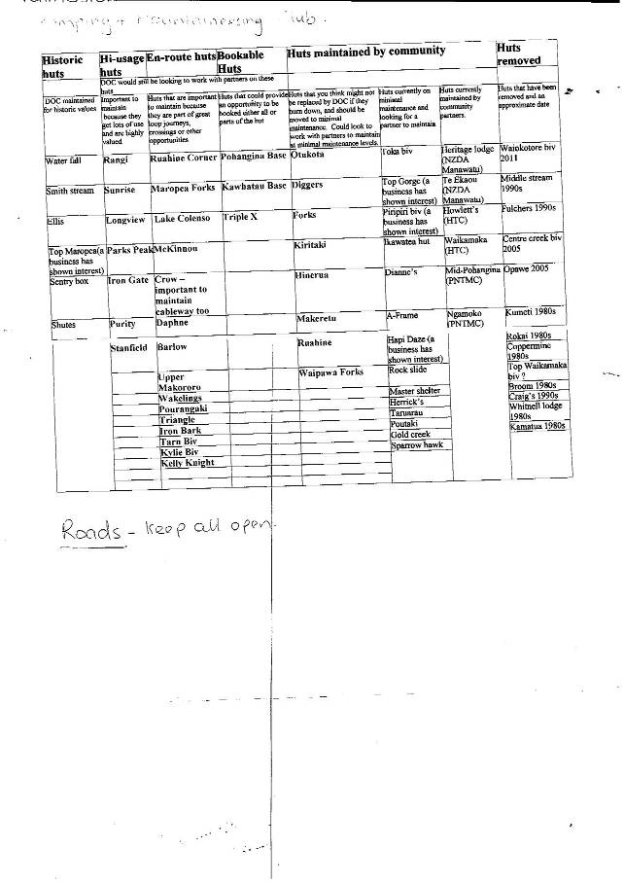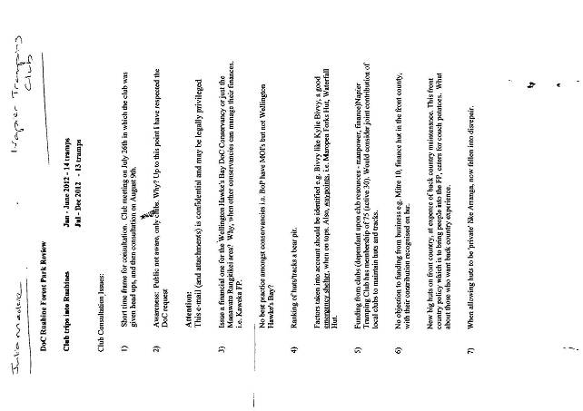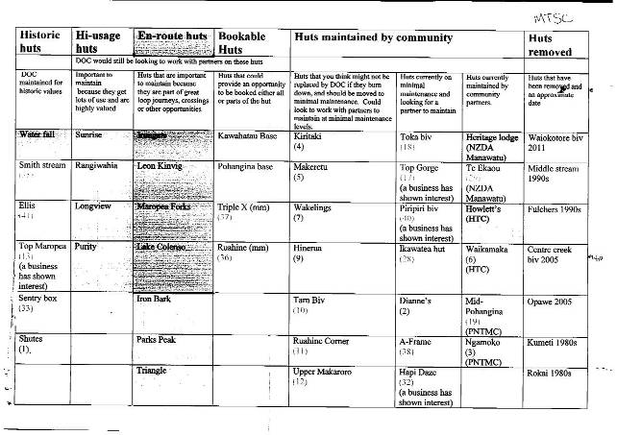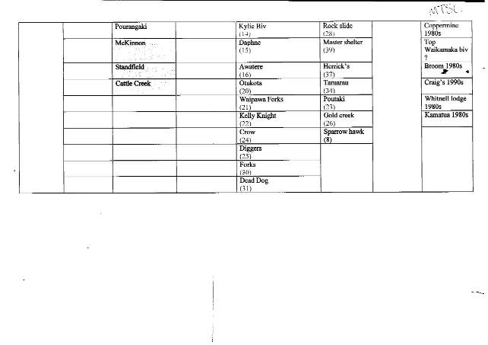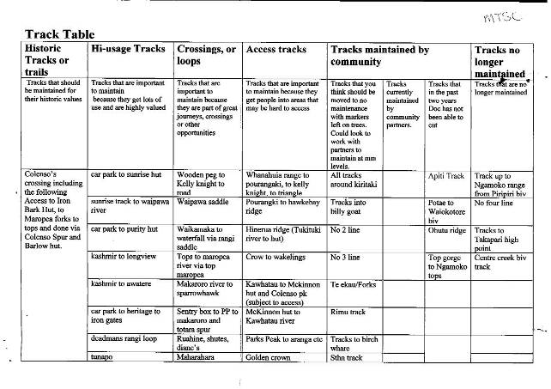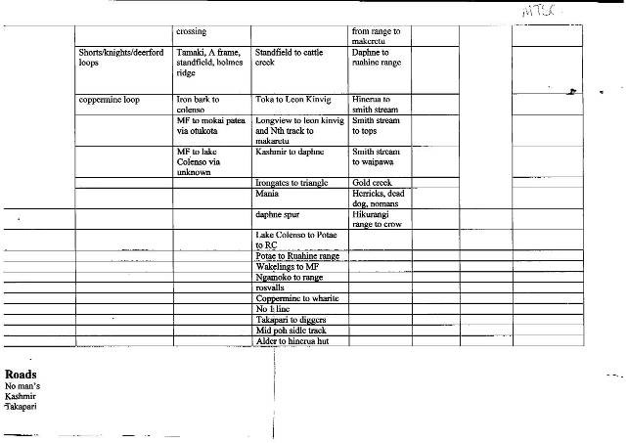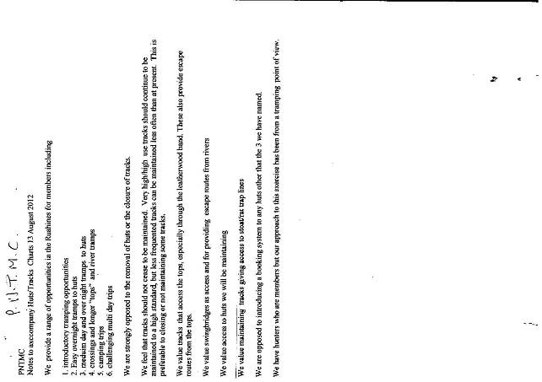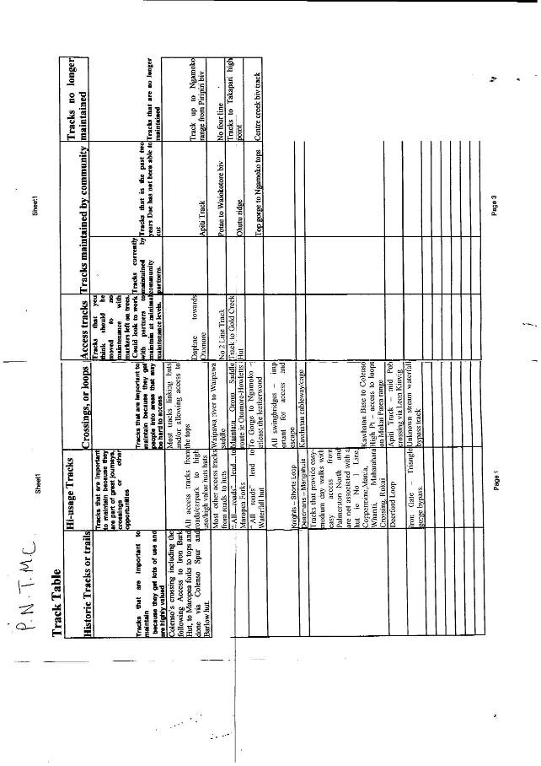

Below is an email from Steve Howl Taihape NZDA

As it turns out, our members are using very few of the ruahines facilities, most were unconcerned by the possibility of no maintenance on some of them. Some were of the opinion that most huts and tracks being used frequently are in a good enough state to stand a few years of no or minimal attention.

10 most frequented facilities used by TAIHAPE NZDA MEMBERS:

2096 Mokai road end to Otukota hut
2105 Hikurangi range to crow hut track
822 Kawhatau road end
Waklings hut
Maropea forks
Ikatwatea forks hut
2120 Purity car park
2117 heritage lodge to Iron Gate hut
2114 Iron gate to triangle hut track
820 Oroua car park to heritage

These cuts to your budget may not be the most ideal of circumstances but, we understand the necessity behind your course of action and support what ever outcome you feel serves all parties needs. We would be more concerned if there was any move to remove huts and facilities but gladly there is no suggestion of that. Thanks for the opportunity to have some input on this matter.

Steve Howl
Taihape NZDA

